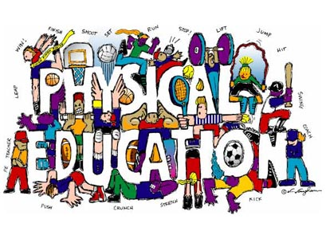

Dear Parents and/or Guardian,

Welcome to a new year of Physical Education at Mary R. Fisher Elementary. I would like to take this opportunity to introduce myself. My name is Erin Longino and I will be your child’s Physical Educator. I have a degree in Physical Education with a minor in Health. I am beyond excited to meet and work with your child this year. As an educator, I passionately feel that all students deserve the opportunity to experience the benefit and joy involved in physical activity. That is why I feel it is essential to create a warm and challenging environment where students feel comfortable to be themselves and try new things.
My goal is to help children find a variety of ways to enjoy being physically active so that they will be able to get all of the physical, emotional, intellectual and social benefits that come to someone who is physically active. My curriculum will offer a wide array of different activities to promote skill and cognitive development, cooperation and success. I also strive to integrate other valuable core subjects into my lessons to reach varying interests and promote further practice.
In order to provide the best possible experience for your child, we must work together as a team! Please remind your child to dress appropriately for physical activity. For comfort and safety purposes, your child should wear sneakers with rubber soles on the day they have P.E.
I look forward to meeting you during our Curriculum Night, Parent Conferences, and other PE special events that will be announced on the MRFES website. Please feel free to contact me with any questions or concerns. My email is elongino@thompsonpublicschools.org

Warm Regards,

Mrs. Longino
Physical Education

