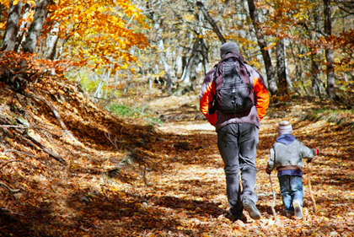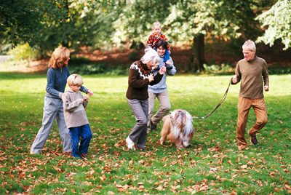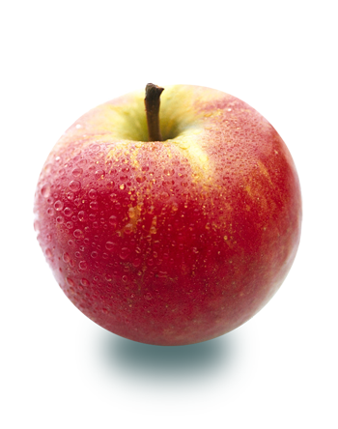

**Are you looking for fun family activities to do this fall? Look no further! Turn off the tv, walk away from that computer, put that phone down, and get your family active with these easy autumn activities.**

1. **Play in the leaves–** Okay, so maybe do a bit more than play. Make household chores fun for kids and adults by choosing an outdoor chore like clearing leaves from the yard, and making it a whole family project? Everyone should have a job so the whole family works together to complete the project. Someone rakes, someone else picks leaves up and places them in a bag or bin, another person loads the bins into the car. Depending on the size of your yard and family, maybe there’s someone using a leaf blower to round the leaves up. Make it interesting and divide into two teams and race each other. Don’t forget to jump in the leaf pile!
2. **Take a hike**– Go on a family hike and take advantage of the fall foliage. The higher you hike, the better the view! If hiking is not an option, a walk around the neighborhood would be just as beautiful and beneficial.
3. **Family bike ride**- With the trees looking so beautiful and the sun shining, get the family together to go on a bike ride around the neighborhood. Remember to always wear your helmets!
4. **Fall Scavenger Hunt–** Have an autumn themed scavenger hunt. Create a list of things you can find outside in the fall like pinecones, yellow leaves, acorns, and crabapples, and race to see who can find them all first. If this is too easy, make riddles for each item so participants have to figure out what the item is before they can begin to search for it.
5. **Visit a farm–** Take the family to your local farm and enjoy apple and pumpkin picking, hayrides, and corn mazes. If there are no farms in your area, the local farm stand, or the farmer’s market can offer a similar experience.

**MOVING TOGETHER**