SPRING INTO ACTION
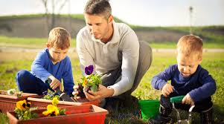
FUN IDEAS FOR SPRING

Plant something green and watch it grown
Some dirt, water, & sunlight are all you need to make a seed come to life

Have a picnic at a local park.
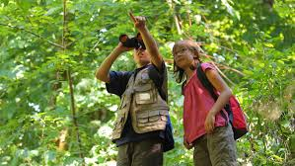
Grab a blanket and some snacks
and enjoy a lunch in the beautiful
outdoors. Check out the scenery.

Play softball or catch.
A glove and a ball is all you need to practice throwing and catching.

Family bike ride or walk to see what’s growing.
Remember to wear your helmet!
SAFETY FIRST

